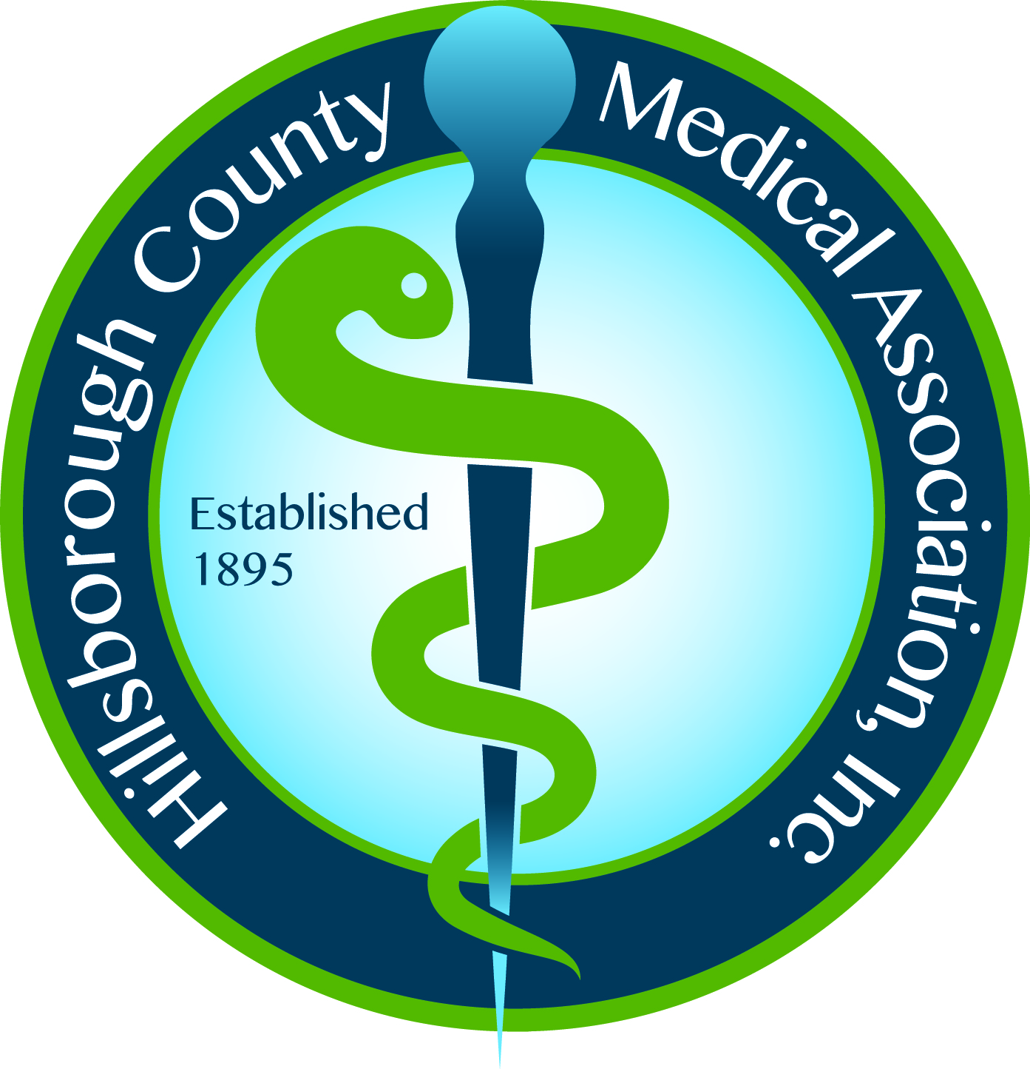 Hillsborough County Medical Association, Inc.
606 S. Boulevard, Tampa, FL 33606
813/253-0471 ~ 813/253-3737 fax
www.HCMA.net

Dear Medical Student,

It is a pleasure to welcome you as a member in the Hillsborough County Medical Association (HCMA).

If you are also a member of the Florida Medical Association (FMA) you are invited to attend the HCMA general membership dinner meetings (at no cost) which are held four times per year. The time and location of the meetings are listed in each issue of The Bulletin and included on the HCMA website. You will also receive a meeting notice via email. It is very important that you remember to sign in at all dinner meetings.

As with any HCMA member, medical students must call to cancel reservations three business day in advance of the meeting. Medical Students are responsible for the cost of their guest/s meal. We hope you will be able to attend the dinner meetings and encourage attendance at any of the HCMA’s Council or Committee meetings throughout the year.

Please remember to notify the HCMA regarding any address, phone, and/or email changes. It is important that the HCMA maintain up to date information in our database.

One of the privileges to which you are entitled is the service of the HCMA office staff. You are encouraged to call the HCMA office at 813/253-0471 anytime you have questions or need assistance.

Again, welcome to the HCMA. I am confident that your membership will better help you prepare for the challenges ahead as you pursue a degree in one of the most revered professions in our nation.

Sincerely,

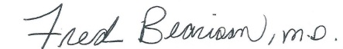

Fred Bearison, M.D.
President

