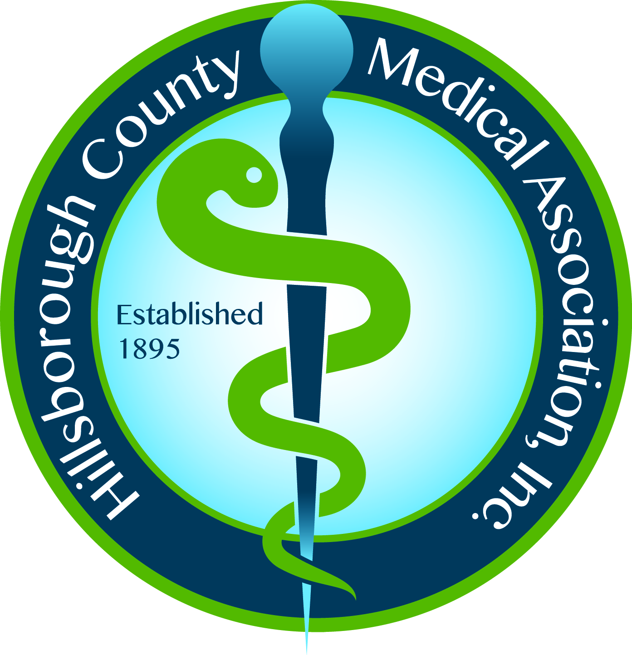Hillsborough County Medical Association, Inc.
606 S. Boulevard, Tampa, FL 33606
813/253-0471 ~ 813/253-3737 fax
www.HCMA.net

Dear Resident Physician,

It is a pleasure to welcome you as a member in the Hillsborough County Medical Association (HCMA).

As a member, you are invited to attend the HCMA general membership dinner meetings which are held four times per year. The time and location of the meetings are listed in each issue of The Bulletin and included on the HCMA website. You will also receive a meeting notice via email. We also encourage attendance at any of the HCMA’s Council or Committee meetings throughout the year. It will allow you the opportunity to learn more about the HCMA and our dedication in helping physicians practice medicine.

One of the privileges to which you are entitled is the service of the HCMA office staff. You are encouraged to call the HCMA office at 813/253-0471 anytime you have questions or need assistance.

Please remember you must have an application on file with the HCMA and notify the office regarding any address, phone, and/or email changes. It is important that the HCMA maintain up to date information in our database.

Again, welcome to the HCMA. As the Association continues serving as your advocate, helping preserve the profession of medicine, I am confident that your membership will better help you prepare for the challenges ahead.

Sincerely,

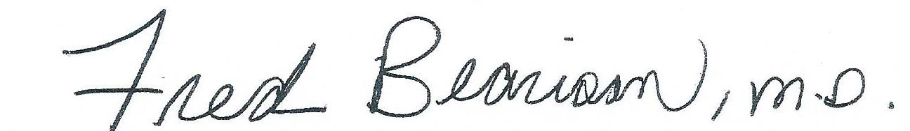

Fred Bearison, M.D.
President

